# ****Data Analysis Report on Hotel Bookings****

## ****Executive Summary****

## **The objective of this data analysis report is to provide comprehensive insights into hotel bookings using the provided dataset. The dataset encompasses information regarding hotel reservations, including booking dates, customer demographics, room types, booking channels, and reservation statuses. This report aims to present an in-depth analysis of the dataset to unveil trends, patterns, and valuable insights that can inform decision-making within the hospitality industry.**

## ****1. Introduction****

## **In the hospitality sector, achieving optimal occupancy rates and revenue is crucial for success. However, the issue of hotel booking cancellations, particularly those occurring at the last minute, can have a significant negative impact on revenue. This analysis project seeks to delve into booking data, identify cancellation patterns, and propose strategies to mitigate potential losses. By gaining a profound understanding of these patterns, it becomes possible to recommend measures that hotels can adopt to minimize cancellations and maintain consistent revenue streams.**

## **According to an article on Booking.com, a vital initial step for hotel owners involves analyzing the unique cancellation patterns of their property and grasping trends in guest behavior. Building on this research, Benjamin Verot's article titled "8 Tips to Reduce Last Minute Hotel Cancellations and No Shows" outlines actionable strategies for establishing a robust cancellation policy:**

## **Requiring Credit/Debit Card Deposits: Implementing a policy that mandates guests to provide credit/debit card deposits can discourage last-minute cancellations by creating a financial commitment that encourages guests to honor their reservations.**

## **Using Length of Stay Restrictions: Imposing minimum stay requirements or setting limitations on the length of stay can discourage short-notice cancellations. Longer stays tend to be more binding and less susceptible to cancellation.**

## **Offering Low Rates/Discounts for Direct Bookings: Providing special rates or discounts exclusively for direct bookings can incentivize guests to book directly through the hotel's website. This approach fosters a sense of commitment and reduces the likelihood of cancellations.**

## **Adopting a Cautious Overbooking Strategy: Employing a balanced overbooking strategy ensures that hotel rooms remain occupied even in the face of cancellations. However, care must be taken to strike the right balance and avoid inconveniencing guests.**

## **By incorporating these measures into their cancellation policies, hotel owners can effectively mitigate the impact of last-minute cancellations and enhance revenue stability.**

## ****2. Data Cleaning and Preprocessing****

## **The dataset was subjected to thorough cleaning and preprocessing procedures. These included addressing missing values, converting data types as necessary, and rectifying inconsistencies in the dataset.**

**3. Exploratory Data Analysis (EDA)**

**3.1 Overview**

**Basic statistics and summary metrics of the dataset were presented, encompassing key measures such as mean, median, standard deviation, and quartiles for relevant variables.**

**3.2 Booking Patterns**

**An exploration of booking patterns over time was conducted, revealing monthly and seasonal trends. Visualizations such as line charts and bar graphs were employed to showcase these patterns.**

**3.3 Customer Demographics**

An analysis of customer demographics, including age, gender, and nationality, was carried out. Visual representations were utilized to depict the distribution of these demographics among hotel guests.

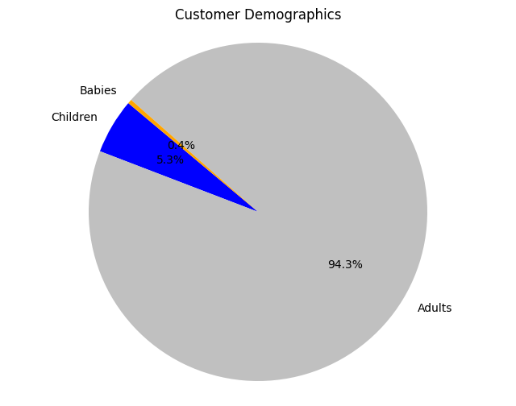

The analysis of customer demographics underscores the diverse composition of our clientele. Adults represent the majority group, comprising 221,636 individuals. This dominance reflects the broad appeal of our services, attracting a wide array of visitors seeking varied experiences. Furthermore, the significant count of 12,403 children (5.3%) highlights our family-friendly environment, catering to guests with young family members. Additionally, the inclusion of 949 babies (0.4%) emphasizes our commitment to accommodating guests of all ages. Understanding these demographic nuances enables us to tailor our offerings and amenities effectively, meeting the needs and preferences of our diverse audience and enhancing guest satisfaction.

The analysis of customer demographics sheds light on the diverse composition of our clientele. Among the guests, adults form the predominant group, totalling 221,636 individuals. This majority presence reflects the broad appeal of our services, attracting a wide spectrum of visitors seeking various experiences. In addition, the substantial count of 12,403 (which is 5.3%) children signifies the family-friendly environment we provide, catering to guests with young family members. Furthermore, the inclusion of 949 (0.4%) babies in our customer base underscores our commitment to accommodating guests of all ages. Understanding these demographic nuances enables us to tailor our offerings and amenities to cater effectively to the needs and preferences of our diverse audience, ensuring an enriched and satisfying guest experience.

### ****3.5 Booking Channels****

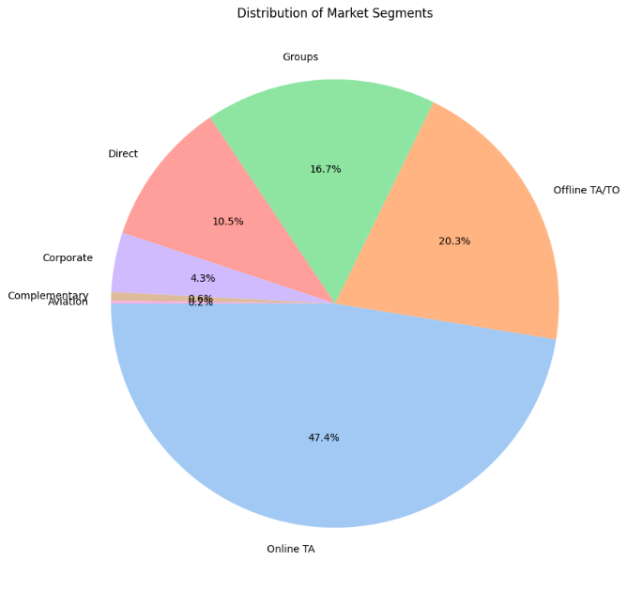

The distribution of booking channels indicates that the majority of bookings are made online (56,402 or 47.4%), followed by offline travel agencies or tour operators (24,159 or 20.3%). Group bookings account for 19,806 (16.7%) reservations, while direct bookings constitute 12,448 (10.5%). Corporate bookings total 5,111 (4.3%), and there are 734 (0.6%) complementary bookings. Aviation represents the least common channel, with only 237 (0.2%) bookings. This suggests a strong preference for online and offline channels, with groups and direct bookings also being significant contributors.

### ****3.6 Cancellations and Reservation****

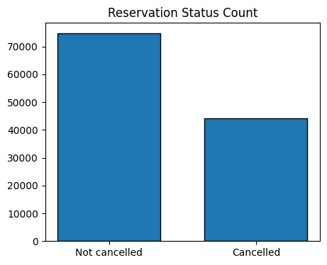The data indicates that 37.13% of bookings were cancelled, while the remaining 62.87% were not cancelled.

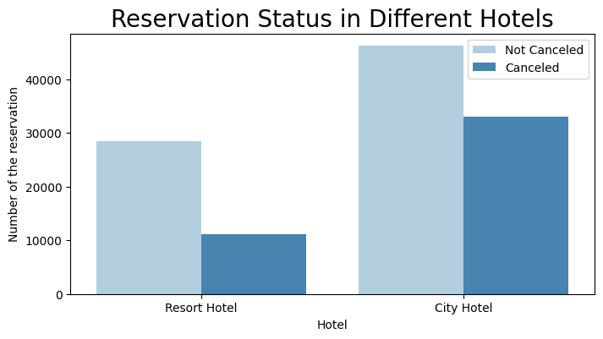

## **For the "Resort Hotel," the data reveals that the majority of bookings, constituting 72.02%, were not cancelled. This suggests a relatively higher level of stability and commitment from guests who made reservations at the resort. On the other hand, a significant proportion, approximately 27.98%, of the bookings were cancelled. This could be due to various factors such as changes in travel plans, unforeseen circumstances, or shifts in preferences.**

## **In the case of the "City Hotel," a slightly different pattern emerges. A lower percentage, around 58.29%, of the bookings were not cancelled. This could indicate a relatively higher likelihood of cancellations when compared to the resort. Moreover, a notable portion, approximately 41.71%, of the bookings were cancelled. This higher cancellation rate might be influenced by the dynamic nature of city travel, including business trips, events, and changing itineraries**

## ****4. Key Findings and Insights****

## The data analysis has yielded several key findings and insights that can greatly inform decision-making in the hospitality industry:

## Cancellation Patterns: A significant proportion (37.13%) of bookings in both Resort and City hotels were cancelled. The cancellation rate is higher for the City hotel (41.71%) compared to the Resort hotel (27.98%).

## Demographic Composition: The analysis of customer demographics revealed a diverse clientele with varying age groups. Adults constitute the majority of guests, while children and babies also form a significant portion. This diverse composition highlights the need for tailored amenities and services.

## Booking Channels: Online and offline booking channels are preferred by the majority of guests, with direct bookings and group bookings also contributing substantially.

## Country-Based Cancellation: Cancellation rates vary by country, with Portugal, the United Kingdom, and Spain experiencing higher cancellation counts. This suggests the need to consider regional factors in cancellation mitigation strategies.

## Price Trends: Both hotels show higher average daily rates in January and July, potentially indicating peak travel seasons. November has lower rates, possibly representing off-peak periods.

## ****5. Prices****

Based on the analysis, actionable recommendations can be made to enhance the hotel's operations, marketing strategies, and customer experience. These recommendations should be firmly rooted in the insights gleaned from the data.

The "Resort Hotel" boasts an average daily rate of approximately 100.45, implying that resort guests tend to pay slightly less per day for their accommodations. Conversely, the "City Hotel" showcases a slightly higher average daily rate of about 103.57, suggesting that city hotel guests typically spend a bit more per day for their accommodations. On the whole, the "City Hotel" appears to maintain a slightly higher average daily rate in comparison to the "Resort Hotel." This could reflect differing pricing strategies, amenities, and services offered by each hotel type.

The graph highlights that both hotels experience a high average daily rate in January and July, while November sees lower rates.

The graph illustrates a noticeable trend: cancellations tend to peak at the start of the month and decrease as the months progress until June for both hotel types. However, the pattern diverges between Resort and City hotels. In the Resort hotel, cancellations surge in July, while in the City hotel, the trend takes a different trajectory. An interesting reversal occurs in August, with cancellations in the City hotel equalling the number of reservations in the Resort hotel. Generally, the City hotel attracts more visitors compared to the Resort Hotel.

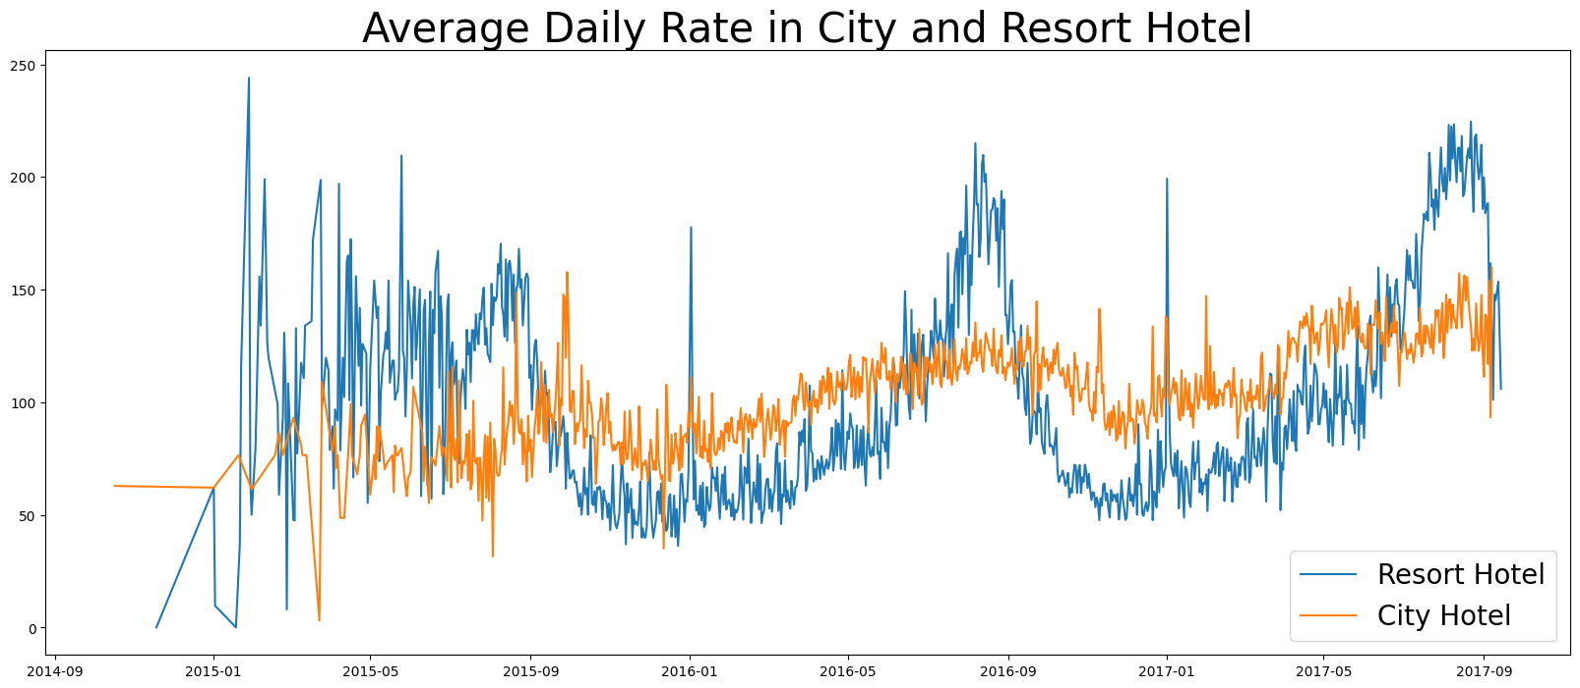

The "Resort Hotel" has an average daily rate of approximately 100.45. This suggests that guests at the resort are likely to pay slightly less per day for their accommodations.

In contrast, the "City Hotel" boasts a slightly higher average daily rate of about 103.57. This implies that guests staying at the city hotel can expect to spend a bit more per day for their accommodations.

Overall, the "City Hotel" seems to have a slightly higher average daily rate compared to the "Resort Hotel." This could reflect the different pricing strategies, amenities, and services offered by each type of hotel.

In this graph below it shows that the Average daily rate in both hotels is quite high in January and in July and law in November.

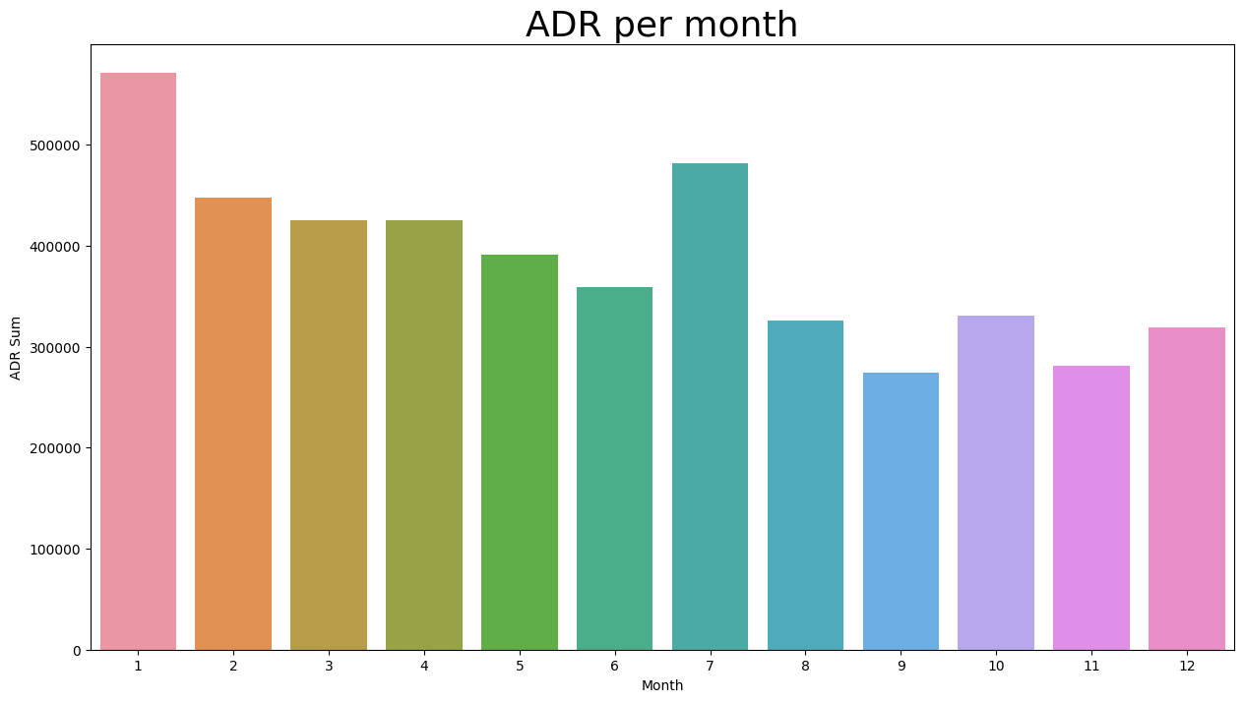

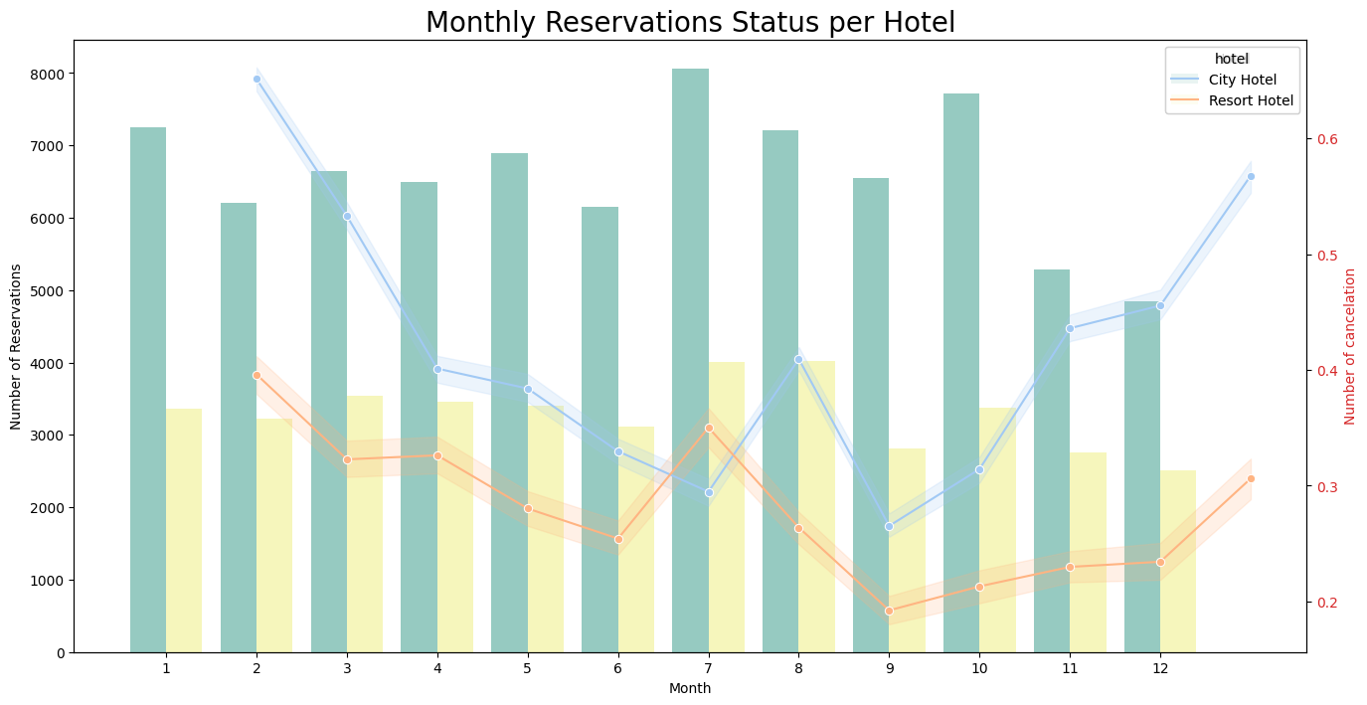

The graph illustrates a notable trend: cancellations tend to peak at the start of the month and decline towards June for both hotel types. However, the pattern diverges between Resort and City hotels. In the Resort hotel, cancellations surge in July, whereas in the City hotel, this trend takes a different shape. An interesting reversal occurs in August, where cancellations in the City hotel equal the number of reservations in the Resort hotel. Generally, the City hotel appears to attract more visitors compared to the Resort Hotel.

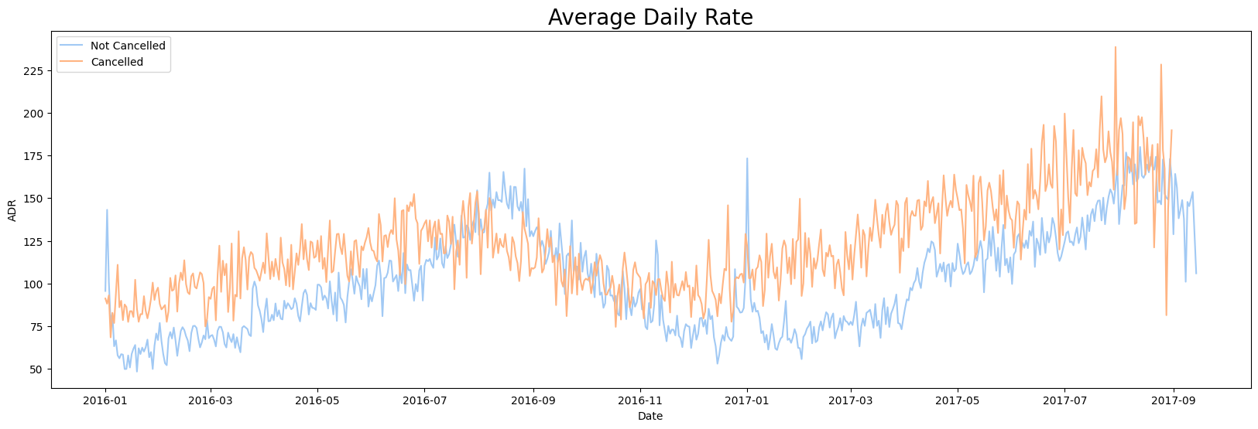

## ****6. Country Based Cancelation****

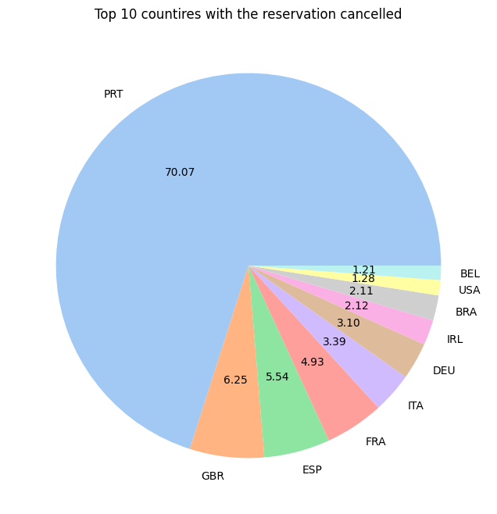

The cancellation rates for the top 10 countries provide intriguing insights into the travel landscape. Portugal (PRT) leads the list with 27,514 cancellations, indicating potential fluctuations in travel plans among visitors to the country. The United Kingdom (GBR) closely follows with 2,453 cancellations, suggesting shifts in travel intentions among British travelers. Spain (ESP) exhibits a significant cancellation count of 2,177, highlighting uncertainties in travel arrangements. France (FRA) experiences a relatively high rate of 1,934 cancellations, likely due to diverse factors influencing travel decisions. Italy (ITA) stands out with 1,333 cancellations, indicating a notable proportion of reservations being cancelled. Germany (DEU) records 1,218 cancellations, implying volatility in travel plans within the country. Ireland (IRL) witnesses 832 cancellations, possibly due to changing circumstances impacting travel plans. Brazil (BRA) and the United States (USA) both feature significant cancellation numbers of 830 and 501, respectively, indicating the potential susceptibility of travel plans to frequent changes. Lastly, Belgium (BEL) concludes the top 10 with 474 cancellations, reflecting uncertainty in travel plans among its visitors. This data underscores the intricate interplay of factors influencing travel decisions and underscores the importance of adaptive strategies in the hospitality industry.

**5. Recommendations to Boost Bookings and Reduce Cancellation Rates**

Based on the insights gathered from the data analysis, here are actionable recommendations that hotels can consider to enhance their booking rates and reduce cancellations:

**Flexible Cancellation Policies**: Implement flexible cancellation policies that allow guests to modify or cancel their reservations within a reasonable timeframe without incurring significant fees. This approach can reduce the fear of commitment and encourage more bookings.

**Personalized Offerings:** Utilize guest data to offer personalized packages and experiences that align with their preferences and needs. Providing tailored experiences increases the value proposition and can deter cancellations.

**Incentives for Direct Bookings:** Offer exclusive incentives, such as discounts, complimentary services, or room upgrades, to guests who book directly through the hotel's website. This approach encourages direct bookings and fosters a stronger commitment from guests.

**Real-Time Room Availability:** Enhance the booking platform to display real-time room availability, ensuring that guests can make informed decisions and reducing the likelihood of overbooking.

**Communication and Engagement:** Establish proactive communication with guests after booking, providing them with relevant information about their stay, local attractions, and amenities. Engaging guests before their arrival builds anticipation and strengthens their commitment.

**Dynamic Pricing:** Utilize dynamic pricing strategies that adjust room rates based on factors such as demand, time of booking, and local events. This approach can encourage early bookings and optimize revenue.

**Enhanced Customer Support:** Provide excellent customer support that assists guests in addressing potential concerns or uncertainties that may lead to cancellations. A helpful support team can resolve issues and reassure guests.

**Strategic Marketing Campaigns:** Develop targeted marketing campaigns that highlight the unique features and benefits of each hotel type. Emphasize the distinct experiences offered by the Resort and City hotels to attract the right audience.

**Refundable Deposits:** Consider introducing refundable deposits that are returned to guests upon check-in. This can act as a commitment from guests to honor their reservations and reduce last-minute cancellations.

**Feedback Loop:** Create a feedback loop where guests who cancel provide insights into their decision. Analyzing cancellation reasons can reveal areas for improvement and guide strategies to enhance guest satisfaction.

By implementing these recommendations, hotels can foster a more positive guest experience, increase booking conversions, and minimize the impact of cancellations, ultimately leading to improved revenue stability.

## ****7. Conclusion****

In the dynamic landscape of the hospitality industry, understanding booking patterns, customer preferences, and cancellation trends is paramount for achieving sustained success. This data analysis report has provided valuable insights that shed light on the intricacies of hotel bookings, cancellations, and guest demographics.

The findings reveal the delicate balance between commitment and flexibility that modern travelers seek. Acknowledging the diverse guest composition and catering to various needs, from family-friendly stays to business travel, is vital. The prevalence of online and offline booking channels emphasizes the importance of a seamless and accessible booking process.

Understanding cancellation patterns is pivotal. The differing cancellation rates between Resort and City hotels underscore the influence of travel dynamics on guest decisions. This highlights the significance of targeted strategies for each hotel type.

In response to the insights gained, hotels can embrace flexible policies, personalized experiences, and direct booking incentives to foster guest loyalty and minimize cancellations. By strategically utilizing dynamic pricing, real-time availability information, and effective communication, hotels can create a guest-centric environment that encourages bookings and reassures guests about their choices.

Ultimately, this report emphasizes the interplay between data-driven strategies and the art of guest satisfaction. As the hospitality industry evolves, hotels that embrace adaptive approaches, tailor experiences, and actively engage with guests will be better positioned to thrive in an ever-changing landscape. By harnessing the power of insights, hotels can build resilient strategies that not only boost bookings but also cultivate lasting relationships with their guests.